Dr. Hawkins’ Tips on how to effectively study/prepare for exams/quizzes

1. Take good notes by hand and be an active and engaged listener/learner
a. listen first, process, then write
b. ask questions for clarity/big ideas/curiosities or new questions that arise
c. respond to questions posed by teacher
d. ask teacher to slow down or repeat anything if necessary
e. leave space open on the left-hand side of your notes to write questions to help you review/jot down main ideas/reflections/big picture ideas/draw pictures/create mnemonic devices; leave space at the bottom to summarize notes on that page (Cornell-Note taking)
2. Review your notes for the current unit/period every 2-3 days (10-15 minutes each time); if using Cornell-note taking strategy, write questions/reflections/big picture ideas on the left and summarize notes on the bottom. Later cover your notes with a piece of paper and quiz yourself. Teaching others (i.e. a study group) is also an effective way of committing information to long-term memory (learning twice!)
3. One to three days before the test/quiz:
Work on and complete any study guides
Write-out notecards for key terms/ideas and connect these by organizing them based on chronological order, themes, and/or what they have in common. History is a story not a random set of facts!
**Spend 20-30 minutes each night (but no more) before the test or quiz reviewing notecards and making as many connections with the material as you can. The more separate times you review the better chance the information will go from short term memory to long term memory
Look back over classwork/primary source assignments to connect to main ideas of the unit (add any observations or questions you have/notice to your notes)
4. Ask for help/review with teacher/continue asking questions you may have up to the test or quiz
5. Get a good night sleep the night before (8-9 hours) and make sure to drink plenty of water/eat a good breakfast the morning of. Your brain functions better on rest and with food! Dehydration and hunger leaves you more fatigued/prevents your brain from performing and recalling what you know/have learned.
THE CURVE OF FORGETTING

How memory works is not a big mystery. We can easily remember the ideas, items, and information that we turn our attention to often, and we can quickly forget the ideas, items, and information that we “touch” only once or twice. This natural forgetfulness of information we touch only once or twice is a quality of a healthy mind--after all, why store information we tell our minds we won’t need? So the point is simple: We tell our memories what’s important to store by how many times we practice retrieving the information. The more times we practice—the more times we touch the information--the more permanently the information will be stored.

The Curve of Forgetting graph below (originally called The Ebbinghuas Curve after the German philosopher Hermann Ebbinghaus who developed it in 1885) demonstrates how quickly we forget new information we don’t work with repeatedly. Here’s what the graph demonstrates: Assume that we hear ten new terms in class on Monday. Our immediate recall, Point A of the graph, is 100%--we can repeat the terms and definitions at the point where we first encounter them.

However, if we do not repeatedly return our attention to these terms and definitions, we will forget about 40% over the first 24 hours. If we wait another 24 hours before reviewing the information, we have lost 60%. So we can go from a grade of ‘A’ (100%) to ‘D’ (60%), to ‘F’ (40%) in just 48 hours.

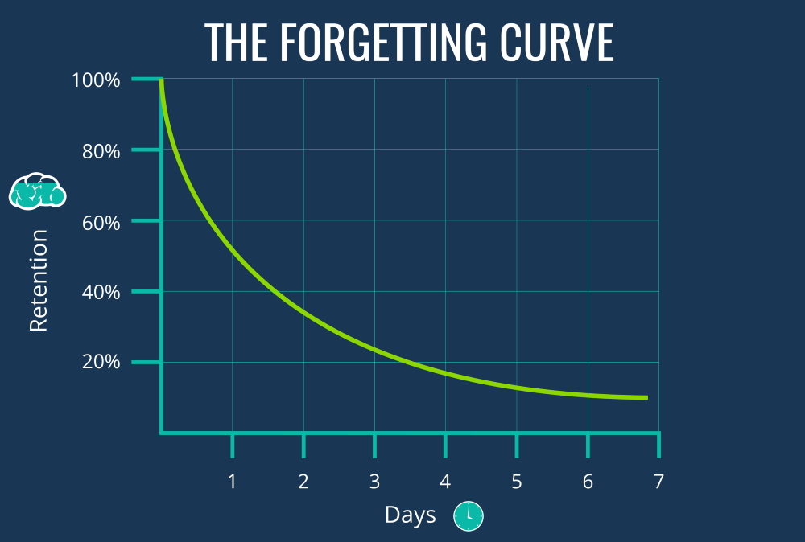

This is the deception of temporary memory: When we first hear something, because we can immediately think about it and repeat it, we assume we will remember it from then on. However, what has really happened is that our brains have attached a drop of temporary memory “glue” to the information. (There really is a scientific name for the chemicals that bind the memory).

In a short time, this drop of temporary “glue” loses its bond and we forget the information. But if we continually return our mind’s attention to this information, if we continually add more drops of “glue,” eventually the information will become part of more permanent memory.

We add new drops of “glue” by first getting to the new information as soon as we can after we first hear or read it. Then occasionally but continually we review the material, often quizzing ourselves on it. Our study goal is to “touch” the information often, in little review sessions, with a bit of time in between sessions.

The “Trickle-in Method”

Here is how to use the Trickle-in Method”: Assume that you have a 25-term vocabulary test facing you on Friday, so you begin to “trickle in” the information on Monday or Tuesday, not the night before the test. You put each vocabulary word on a separate 3-by-5 card with its definition on the back. You carry these cards in your pocket or purse. You go through the cards and quiz yourself on the ten-minute bus ride in the morning. That same day before lunch, you quiz yourself again. Five minutes before your favorite soap or Oprah starts, you look at the cards again. While supper is cooking, you give yourself another quiz. Just before you go to bed, you quiz yourself once more.

Time spent to do this: four or five 10-minute periods. If you continue to do this each day, you will do very well on the test Friday, and you will not have missed the time you used to study. You have touched the information several times in little bites (you have “trickled in” the information) and will have fairly permanent knowledge of this material. This is good news for the final, too, because the information has a good chance of staying in your mind the rest of the term.

A FEW MORE HINTS

1. Try to study in the same place as much as possible. Humans tend to get “conditioned” to doing a certain activity in a certain place. Studying in the same location allows us to get to work much sooner.

2. Try scheduling classes and study periods when you are most alert. For example, if you are a "morning person," try to organize your schedule accordingly.

In addition, if your life allows, schedule one-hour breaks between your classes (for example, schedule your classes at 8:30, 10:30, and 12:30, so that you have breaks at 9:30 and 11:30). These one-hour breaks allow time to “review and preview”: Review what you just heard in the lecture and preview what the next class will cover.

3. Have a study plan and study according to priorities. Decide beforehand how you will divide your study sessions and use a “to-do” list to organize your time.

4. Break long study periods into shorter segments—20 to 30 minutes and then change subjects or activities. Return to a previous subject or activity later if you need more time for it.

5. Remember—“trickle in” the information--little bites in question/answer format.

6. Keep a calendar of upcoming tests and assignments--begin trickling in the information well before the date, using flashcards when possible.

7. Your grade on a test or in a course is not determined by how many hours you spend studying but by how much quality study time you spend. Study smart--remember--you can waste hours and hours studying improperly.

http://ol.scc.spokane.edu/jroth/Courses/English%2094-study%20skills/MASTER%20DOCS%20and%20TESTS/Curve%20of%20Forgetting.htm

