Cornell Note Taking Method
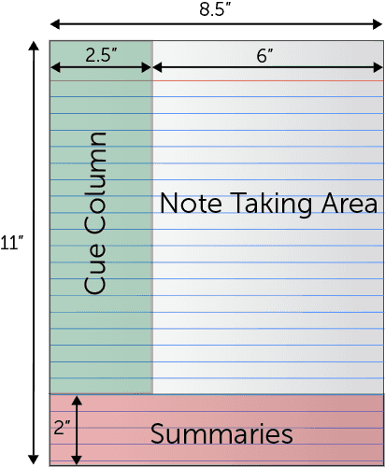
Note Taking Area: Record lecture as fully and as meaningfully as possible.
Cue Column: As you're taking notes, keep cue column empty. Soon after the lecture, reduce your notes to concise jottings as clues for Reciting, Reviewing, and Reflecting. Biggest tip: Write questions on cue side to review later (cover up note taking area with piece of paper when reviewing)
Summaries: Sum up each page of your notes in a sentence or two.
This format provides the perfect opportunity for following through with the 5 R's of note-taking:
- Record
During the lecture, record in the main column as many meaningful facts and ideas as you can. Write legibly.
- Reduce
As soon after as possible, summarize these facts and ideas concisely in the Cue Column. Summarizing clarifies meanings and relationships, reinforces continuity, and strengthens memory.
- Recite
Cover the Note Taking Area, using only your jottings in the Cue Column, say over the facts and ideas of the lecture as fully as you can, not mechanically, but in your own words. Then, verify what you have said.
- Reflect
Draw out opinions from your notes and use them as a starting point for your own reflections on the course and how it relates to your other courses. Reflection will help prevent ideas from being inert and soon forgotten.
- Review
Spend 10 minutes every week in quick review of your notes, and you will retain most of what you have learned.
Adapted from How to Study in College 7/e by Walter Pauk, 2001 Houghton Mifflin Company

https://www.umfk.edu/learning-center/studying-tips/notes/

